**Tutorial 02 – Build WordPress CMS on Multiple Platforms and Extend using Best Practices**

Students are required to have access to a Web Host account that they use to create and manage multiple CMS websites. In our first IT320 class we registered up for a student SiteGround and Codeanywhere web host accounts. In this assignment, you will record information about these accounts and use them to create your first two WordPress CMS sites.   
Additionally, we will do a few PHP problems, to test your understanding of the PHP material we covered in class.   
If you have difficulties completing this assignment, please inform the instructor and consider working with DePaul tutors.

**Instructions for completing template:***Replace* **[bracketed red text]** *with the requested information and change the* ***red text to black text.*** *Do not include full screen shot images, or full screen shots that are reduced in size. Use a snippet tool to capture parts of the screen and insert those images into the template.  
Please answer all questions.***Please do not alter template numbering.  
Each answer and screen capture are worth points. There are 32 total answers for100 points.**

**PART A – Getting started Student Contact Information**

**1. Student Name: [Abel Marin] [A01](1)**

**2. Student Contact Information:   
[marinabe1416@gmail.com] [A02] (2)  
[(630) 608-8570] [A03] (3)**

**Go back to the tutorial instructions and begin working on part B.**

**Part B – Create a WordPress site on a shared web host**

1. Enter the following shared web host WordPress site information **[B.1]**
   1. Shared Web Host Company Name: [ SiteGround ] **(4)**
   2. In Directory Name: [ mod2turtorial2 ] **(5)**
   3. Website Admin Username: [ abelmarin ] **(6)**
   4. Website Admin Password: [ @g%0$VpBY8 ] **(7)**
   5. Database Name: [ wp136 ] **(8)**
   6. Table Prefix: [ wpva\_ ] **(9)**

**Please make sure all B.2 screen capture include the web browser address bar. [B.2]**

1. Take screen captures of the front end client facing WordPress site **[B.2.1]  
   [ A screenshot of a cell phone

   Description automatically generated ] (10)**
2. Take screen captures of the backend administrative WordPress site   
   select the Dashboard > Home **[B.2.2]  
   [ A screenshot of a computer screen

   Description automatically generated ] (11)**

**Go back to the tutorial instructions and begin working on part C.**

**Part C – Create a WordPress site on Pantheon (PaaS)**

1. Enter the following shared web host WordPress site information **[C.1]**
   1. PaaS WordPress site Admin Username: [ website admin username here ]
   2. PaaS WordPress site Admin Password: [ website admin password here ]

**Please make sure all C.2 screen capture includes the web browser address bar. [C.2]**

1. Take screen captures of the front end client facing WordPress site **[C.2.1]  
   [ Paste screen capture here ]**
2. Take screen captures of the backend administrative WordPress site,   
   select the Dashboard > Home **[C.2.2]  
   [ Paste screen capture here ]**

**Go back to the instructions and begin working on part D.**

**Part D – Create a WordPress site on Codeanywhere**

1. Enter the following Codeanywhere web host WordPress site information **[D.1]**
   1. Site Title: [ AJM - Tutorial 02 CA ] **(12)**
   2. Username: [ ajmarin ] **(13)**
   3. Password: [ 1@WLAcFlh(Iq6kUSa% ] **(14)**
   4. Your Email: [ marinabe1416@gmail.com ] **(15)**

**Please make sure all D.2 screen capture includes the web browser address bar. [D.2]**

1. Take screen captures of the front end client facing WordPress site **[D.2.1]  
   [A screenshot of a cell phone

   Description automatically generated] (16)**
2. Take screen captures of the backend administrative WordPress site   
   select the Dashboard > Home

NOTE – Please look at the screen capture you took.

Look at the “AT A GLANCE“ section.   
Does it say WordPress version 5.3.2 running Twenty Twenty THEME?   
**IF NOT THEN you did not follow instructions** and upgrade the WordPress version and change the active theme. Please do so now AND TAKE and post A NEW SCREEN CAPTURE!  
**[D.2.2]  
] (17)**

**Go back to the instructions and continue at Part E.**

**Part E – Introduction to Best Practices**

1. You are looking for a form plugin. The following (see image below) plugin came up while searching the WordPress plugins page.   
   Examine the following WordPress plugin and list the reasons why it is a good idea to consider using or further evaluating it.  
   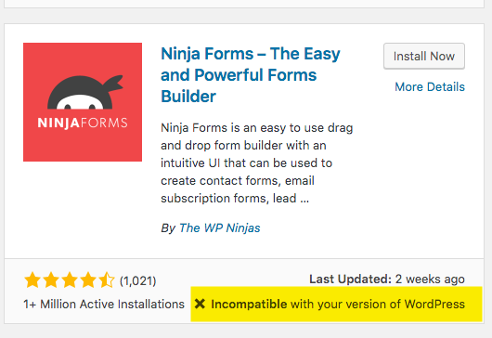  
     
   **[ This plugin should not be considered because it is incompatible with my version of WordPress. ] [E.1] (18)**
2. You are looking for a form plugin. The following (see image below) plugin came up while searching the WordPress plugins page.   
   Examine the following WordPress plugin and list the reasons why it is a good idea to consider using or further evaluating it.  
   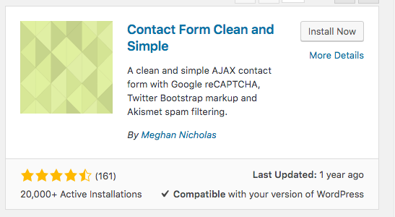  
     
   **[ This plugin should probably not be used since it hasn’t been actively maintained in about a year. Though perhaps you could try it out since it is compatible, has pretty good reviews, and a good about of active instillations. ] [E.2] (19)**
3. You are looking for a meeting tool plugin. The following (see image below) plugin came up while searching the WordPress plugins page.   
   Examine the following WordPress plugin and list the reasons why it is a good idea to consider using or further evaluating it.  
   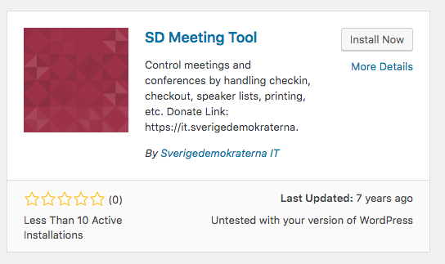  
     
   **[ This plugin should not be considered for use since it is untested with my version of WordPress, it was last updated a very long time ago, very few people are active, and there are no reviews for it. ] [E.3] (20)**
4. You are looking for a form plugin. The following (see image below) plugin came up while searching the WordPress plugins page.   
   Examine the following WordPress plugin and list the reasons why it is a good idea to consider using or further evaluating it.  
   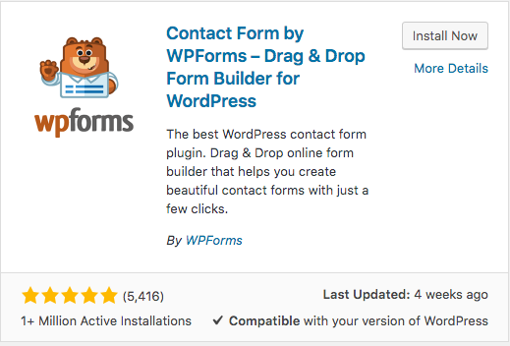  
     
   **[ This plugin should be considered since it has many good reviews, it is actively maintained, has a ton of active installations and is compatible with my version of WordPress. ] [E.4] (21)**
5. While searching for a Google Map plugin, you find the following 2 plugins. Their names appear to be very similar. What steps or process or would you take to determine functional similarities and differences?

|  |  |
| --- | --- |
| HD:private:var:folders:vh:lbh1qypx7zldldk1l9f6tpsc0000gn:T:2019-12-04_09-37-38.png | HD:private:var:folders:vh:lbh1qypx7zldldk1l9f6tpsc0000gn:T:2019-12-04_09-37-21.png |

**[ I would begin by writing out a list of all of my or my clients desired functionality. I would then write out a gap analysis in order to compare which feature each of these plugins had. I would then test out the plugin on a test site. I would then pick which of these to use based on the one which featured the most necessary functionality and which works the best on the test sites. ] [E.5] (22)**

**Go back to the instructions and continue at Part F.**

**Part F – Extend WordPress with Images**

**Please make sure all Part F screen capture include the web browser address bar. [F]**

1. Take screen captures of the backend administration WordPress site Dashboad > Appearance > Media page – with the media library in GRID mode **[F.1]  
   [A screenshot of a computer screen

   Description automatically generated] (23)**
2. Take screen captures of the backend administration WordPress site Dashboad > Appearance > Media page – with the media library in LIST mode **[F.2]  
   [ A screenshot of a computer screen

   Description automatically generated] (24)**

**Go back to the instructions and continue at Part G.**

**Part G – Extend WordPress with Menus**

**Please make sure all Part G screen capture include the web browser address bar. [G]**

1. Take screen captures of the backend administration WordPress site Dashboad > Appearance > Menu page – please make sure the menu Structure and Menu Settings sections are captured **[G.1]  
   [A screenshot of a computer

   Description automatically generated] (25)**
2. Take screen captures of the front-end client facing WordPress site showing the menu items on the home page  **[G.2]  
   [A screenshot of a cell phone

   Description automatically generated] (26)**

**Go back to the instructions and continue at Part H.**

**Part H – PHP QUESTIONS**

**Testing PHP Programs using PHP Emulation Websites:**

* Online PHP test sites:
  + <http://phptester.net>
  + <http://sandbox.onlinephpfunctions.com/>
* How you test your script depends on which test site you use.
* **Each PHP emulation test site works slightly different**.
* Please read the site instructions before testing your PHP code.

1. Write PHP that does the following: **(27)**
   1. Creates 4 variables, with values 1,2,3, and 4
   2. Use an arithmetic operator to add the four variables together and assign the result to a 5th variable named $result.
   3. Display the $result value using an echo statement.

**Test your code using an online PHP test site and paste the code and results in the table cell below.**

|  |
| --- |
| Copy and paste the code block and record the results on the next row. A screen shot from the PHP test site will be the best way to not affect template format. Please try not to change the template numbering or format. |
| \*\*Paste screen capture from your WEB PHP Emulator here \*\* |

1. Write PHP that does the following: **(28)**
   1. Creates 3 variables, with values “xxx”, “zzz”, and “qqq”.
   2. Concatenate all three variables adding a space between each one and assign the result of the concatenation into a 4th variable named $result.
   3. Display the $result value using an echo statement.

**Test your code using an online PHP test site and paste the code and results in the table cell below.**

|  |
| --- |
| Copy and paste the code block and record the results on the next row. A screen shot from the PHP test site will be the best way to not affect template format. Please try not to change the template numbering or format. |
| \*\*Paste screen capture from your WEB PHP Emulator here \*\* |

1. Write PHP that does the following: **(29)**
   1. Creates 2 variables, with values 5 and 10
   2. Write separate lines of code that adds, subtracts, divides, multiplies, and performs a modulus on the 2 variables and displays the result value without an additional variable using an echo statement.

**Test your code using an online PHP test site and paste the code and results in the table cell below.**

|  |
| --- |
| Copy and paste the code block and record the results on the next row. A screen shot from the PHP test site will be the best way to not affect template format. Please try not to change the template numbering or format. |
|  |

1. Write PHP that does the following: **(30)**
   1. Creates 4 variables, with values “My”, “Name”, “is”, “Your Last Name”
      1. Use your actual last name for the Your Name variable
   2. Write PHP code that displays each variable on a separate line of using the HTML break or paragraph TAG

**Test your code using an online PHP test site and paste the code and results in the table cell below.**

|  |
| --- |
| Copy and paste the code block and record the results on the next row. A screen shot from the PHP test site will be the best way to not affect template format. Please try not to change the template numbering or format. |
|  |

1. Write PHP that does the following: **(31)**
   1. Creates 4 variables, with values “My”, “Name”, “is”, “Your Name”
      1. Use your actual name for the Your Name variable
   2. Write PHP code that displays the variables in an HTML 4 row TABLE with a border value of 1.

**Test your code using an online PHP test site and paste the code and results in the table cell below.**

|  |
| --- |
| Copy and paste the code block and record the results on the next row. A screen shot from the PHP test site will be the best way to not affect template format. Please try not to change the template numbering or format. |
|  |

Part H is the last part of this tutorial.   
After finishing the PHP, review your template file and submit it to D2L. You can then start the Assignment. You will need to delete your Codeanywhere container to do the assignment.

**Questions or problems with this tutorial?   
If you have questions or issues about this tutorial please contact the instructor immediately.**

**To get help, either submit an IRT, or make an appointment with the DePaul tutor or connect to BlueStar and make an appointment for an office hours appointment for help.  
If you find errors with this tutorial, please fill out a BRECT form and submit it to the instructor ASAP for Extra Credit points.**

Michael H Chase

Mobile: 847-878-6225

Office: 312-362-1352

Email: [mchase2@cdm.depaul.edu](mailto:mchase2@cdm.depaul.edu)

Submit your completed tutorial template to D2L dropbox for the current weeks tutorial.

If you prefer not to navigate by hand to the D2L dropbox, take advantage of the dropbox link in

the current D2L Module Tutorial section. The D2L link will take you to the correct tutorial dropbox location.